Interaction rules:
Actors: bodies
Actors work asynchronously but sync at barriers
Barrier: at each time step
Broadcast Phase (Async)
Every body:
- Publishes (mass, position, velocity) for time t
- Does this asynchronously
2️⃣ Barrier Phase (Sync)
Wait until:
- All bodies have published state for time t
This gives you a consistent global snapshot.
3️⃣ Compute Phase (Async again)
Each body:
- Computes forces using snapshot(t)
- Updates position/velocity → state(t+1)
Then repeat.

What Each Body Needs Initially
For each body (Sun, planets, comets), you need:
- mass
- position (vector, e.g. x, y, z)
- velocity (vector)
- Gravitational constant G (global)
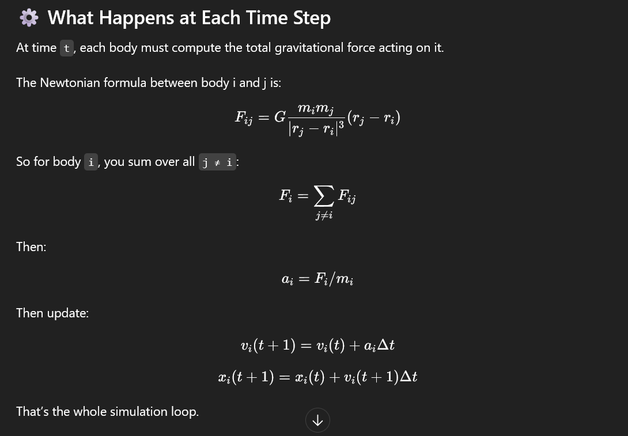
Correct Pattern
At step t:
- Each body sends (mass, position) to coordinator.
- Coordinator builds snapshot = list of all bodies' states at time t.
- Snapshot is broadcast to all bodies.
- Each body:
  - Iterates over snapshot
  - Skips itself
  - Computes total force
  - Updates its own velocity and position
- Barrier → next timestep.
So each body computes only its own next state.
Sun: huge mass
Planets: much smaller
Comet: tiny

Monitoring:
If dominance ratio stays > 0.9 → good
distance_to_sun:
Oscillates around mean → orbit
Grows continuously → escape
Shrinks continuously → collapse

The emphasis is not on astronomical precision, but on correctly modeling pairwise interactions, numerical stability, and efficient distributed computation using Ray.
Load Balancing: Dynamic task scheduling in Ray
Minimizing data transfer between Ray actors/tasks
Scalability: Behavior as the number of bodies and Ray workers increases
You should explore different Ray parallelization strategies and compare their performance.
Measure strong and weak scaling as you add more Ray workers/nodes
Benchmark against a single-node Python implementation

